Press release

Kautex Maschinenbau is celebrating 25 years of machine production in China
Kautex Maschinenbau has been operating a production plant for the manufacture of extrusion blow molding machines in the southern Chinese city of Shunde for 25 years. The presence of this plant means greater proximity to customers and quicker response times for machines, spare parts and service requirements in the Asian packaging market. The company invited customers and partners to an “open house” celebration in Shunde at the start of November to mark the anniversary. Manufacturing capacity there was recently increased to enable even quicker deliveries. A new extended warehouse for spare parts was built in conjunction with the expansion.
Around 200 invited guests from China took up the invitation from Kautex China. In addition to a factory visit with presentations, the program of events also included various specialist lectures and insights into the recently announced product campaigns. The event started in the morning with the Kautex New Machine & New Technology Forum. Kautex employees reported on new “Made by Kautex” technological developments and the imminent product campaigns. New machines and application solutions were presented and guests were informed about the comprehensive range of services offered by Kautex. CEO Thomas Hartkämper presented the new Kautex vision and mission “BeOne – with customers and partners” via video stream. The core of the Kautex mission is the development of intelligent and sustainable production solutions to enable customers to benefit from the highest article quality together with the lowest production costs. The official anniversary celebration with guests and employees took place following the Kautex New Machine & New Technology Forum.
Kautex in the southern Chinese region of Guangdong is a 100% subsidiary of Kautex Maschinenbau GmbH and it was founded in 1995. Kautex employs around 170 people in China.
As well as celebrating a 25th anniversary in China this year, Kautex is also celebrating the 85th anniversary of its original founding in Germany and 60 years of branch establishment in the USA. Plastics pioneer Reinhold Hagen founded the company in 1935. The combination of his passion for experimentation and entrepreneurial aptitude enabled him to succeed in developing the world’s first standard commercial system for the seamless manufacture of plastic containers in 1949.

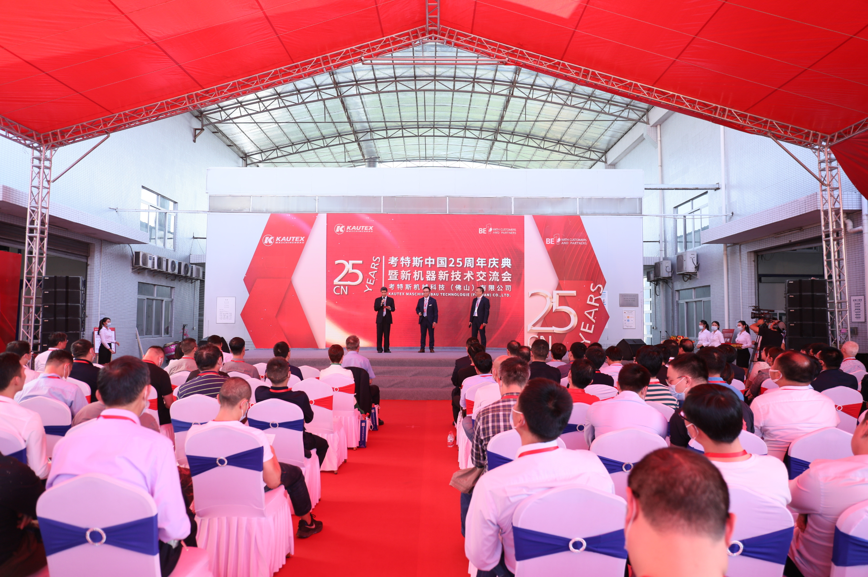
Press image 1 – 25 years of machine production in China
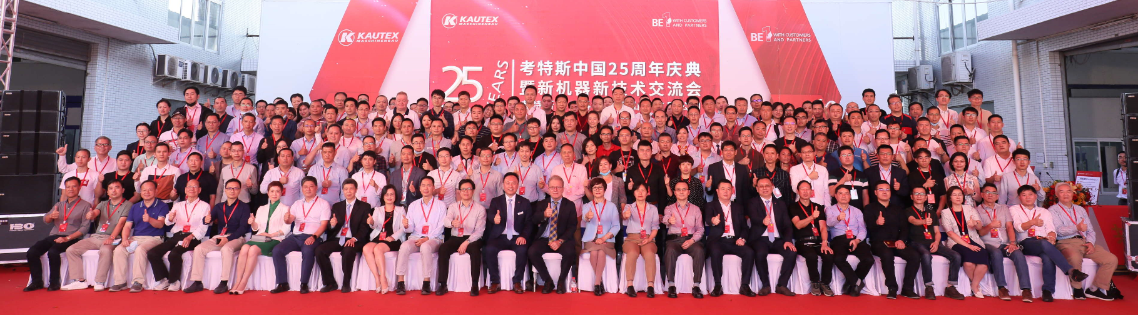
Press image 2 – 25 years of machine production in China

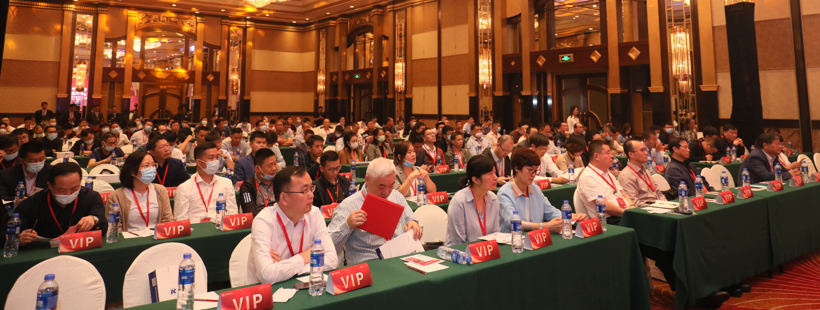
Press image 3 – 25 years of machine production in China

Contact
Christian Kirchbaumer
Head of Marketing Communications
Kautex Maschinenbau GmbH
Kautexstr. 54
53229 Bonn
T +49 228 489370
christian.kirchbaumer@kautex-group.com

